**TABLE OF SPECIFICATIONS FOR EXAM QUESTIONS**

**University of Liberal Arts Bangladesh**

**Department: Computer Science and Engineering (CSE)**

**Final Examinations, Semester: Fall 2020**

**Program: B.Sc. in CSE**

**Course Code: CSE201 Course Title: Object Oriented Programming C++ Credit Hr: 3**

**Time: 2 Hours Total Marks: 25**

**Name & Designation of the Examiner: Satyaki Das, Lecturer**

**Learning Outcomes (LO):**

|  |
| --- |
| 1. **Describe** the principles and concept of OOP |
| 1. **Explain** important features of object-oriented programming that are important to design and develop OOP |
| 1. **Solve** a wide range of practical problems using C++ computer programming language. |
| 1. **Understand** a real-life problem and **be able** to design and code a small system using C++ language |

***Levels in Bloom’s Cognitive Domain:***

***C1: Remember C2: Understand C3: Apply C4: Analyze C5: Evaluate C6: Create***

|  |  |  |  |  |  |  |  |
| --- | --- | --- | --- | --- | --- | --- | --- |
| **Question No.** | **Learning Outcomes (CO)** | **Level in Bloom’s Cognitive Domain along with Allocation of Marks** | | | | | |
|  |  | **C1** | **C2** | **C3** | **C4** | **C5** | **C6** |
| 1 | 1, 3 |  |  | 5 |  |  |  |
| 2 | 2 |  |  |  | 7 |  |  |
| 3 | 4 |  |  | 8 |  |  |  |
| 4 | 4 |  |  |  | 5 |  |  |
| **Total Allocation of Marks** | **25** |  |  | 13 | 12 |  |  |
|  |  |  |  |  |  |  |  |
| **Question No.** |  | **Learning Outcome** | | | | | |
|  |  | **CO1** | **CO2** | **CO3** | **CO4** | **CO5** | **CO6** |
| 1 |  |  |  | 5 |  |  |  |
| 2 |  |  | 7 |  |  |  |  |
| 3 |  |  |  |  | 8 |  |  |
| 4 |  |  |  | 5 |  |  |  |
| **Total Allocation of Marks** | **25** |  | 7 | 10 | 8 |  |  |

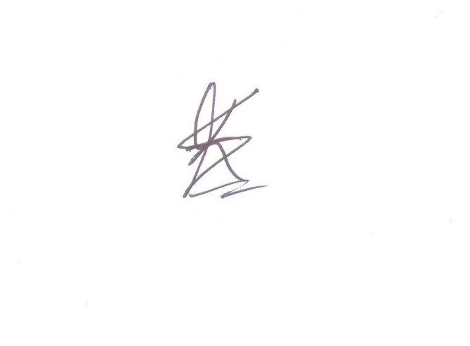

**Signature of the Examiner Date: 11.01.2021**

**INSTRUCTIONS FOR THE FINAL EXAM  
PLEASE CAREFULLY READ THE FOLLOWING INSTRUCTIONS.**  
  
**During the Exam**

1. This is an “open note” exam that allows the students to use any materials handed out in the class, your notes from the lectures, and any other resource that I have already shared with you on Google Classroom.
2. The duration of the exam is 1 Hour 45 minutes and an additional 15 minutes is allotted for answer submission.
3. Show/present all the necessary steps/justifications to derive your answer, where applicable.
4. Showing or discussing anything related to the questions with anyone is prohibited. Hence, usage of any online and offline messaging platforms and external/cloud storage are also strictly prohibited. Further, online searches for preparing your answer are discouraged.
5. Plagiarism policy mentioned in the course outline will be followed.
6. During the entire exam period, you are required to be online over google meet. (The link will be the same as the link for regular classes).
7. You might be randomly asked to turn on your video during the exam. Hence, please ensure necessary arrangements to comply.
8. Please inform me immediately for any disruption via mobile/Whatsapp/FB Messenger.
9. Even if you have Broadband connection in your home, please purchase sufficient internet data on your smartphone to avoid any internet-related disruptions.

**Submission**

1. You must write down your answers on Blank A4 papers with a cover page that contains your Name, Student ID, Course Code, Course Title, Section Number, and “Final Exam- Fall2020”.
2. After completing the exam take pictures or scan your answer script. You may use any scanning app for this purpose.
3. Your student ID should be your file name.
4. Make sure that your handwriting is legible.
5. Questions you are answering must have their numbers written correctly.
6. Make sure that your answer scripts are correctly numbered and sequenced.
7. Upload the PDF file on Google Classroom within 15 minutes after the exam is complete.
8. Failure to submit the answers on time without any valid ground will be considered as late submission. Marks will be deducted in such cases.

**Department of Computer Science and Engineering**

**University of Liberal Arts Bangladesh**

**Final Examination (Fall 2020)**

**Course: Object Oriented Programming C++ (CSE 201)**

**Section: 2 --- Duration: 2 Hours**

**Name & Designation of the Examiner: Satyaki Das, Lecturer**

**______________________________________________________________________________________**

**PLEASE ANSWER ALL QUESTIONS. Total 25 Marks**

**QUESTION 1**

Why should we be careful when using Friend classes or friend functions? Write a function in C++ that reads string from a file, counts the number of vowels in the string and writes the result in another file. Your function should take the names of the input file and output file as parameters. **(2+3=5 Marks)**

**QUESTION 2**

Consider the following class hierarchy:

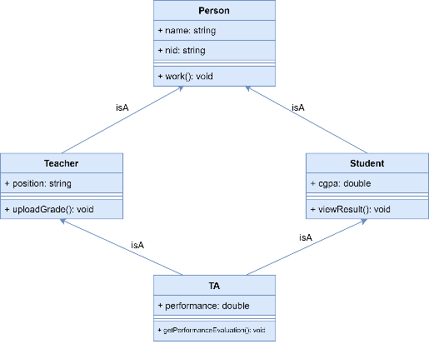

Can you identify any potential problem with the hierarchy? If so point out where the problem is and what will happen if you try to run the above program? **(7 Marks)**

**QUESTION 3**

A program needs a class to represent the time. You are the hired programmer to write the class. Suppose you are naming the class CustomDate. Here is a list of your responsibilities:

* Define the class CustomDate with three integer attributes for day, month and year. The class must also have the following methods:
  + Constructor that takes three parameters and sets the value of each attribute to the value of the parameter with the corresponding name.
  + Constructor that takes no parameters and writes the current date to the corresponding attribute.
  + void print();

outputs time using the the format day/month/year.

* To get current date, include the library ctime and then add the following code:

time_t now = time(0);

tm *ltm = localtime(&now);

month = 1 + ltm->tm_mon;

day = ltm->tm_mday;

year = 1900 + ltm->tm_year;

Implement the code. **(8 Marks)**

**QUESTION 4**

Consider the following program:

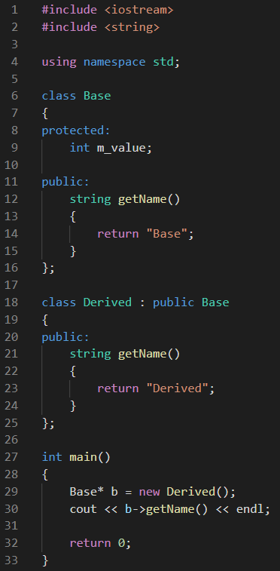

This output of the program is supposed to be “Derived”. Identify the problem with the program and modify the code so that it displays the desired output. **(3+2=5 Marks)**

**\*\*END OF QUESTIONS\*\***